1.11: The density is mass per unit volume, so the volume is mass divided by density.
Use the formula for the volume of a sphere, 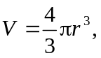
to calculate 